Competitor research (3)
- Salesforce CRM
- Zoho CRM
- Freshsales (Freshworks CRM)
HubSpot USPs (4–5)
- All-in-one platform
- Fast setup + easy adoption
- Strong automation
- Reports that help decisions
- Big integrations ecosystem
Campaign setup (Quora Ads)
a) Selected objective
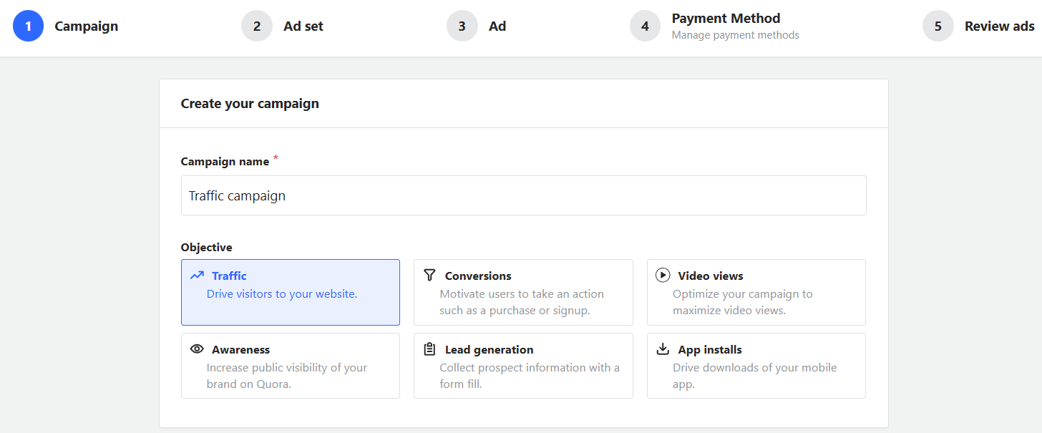b) Budget setup
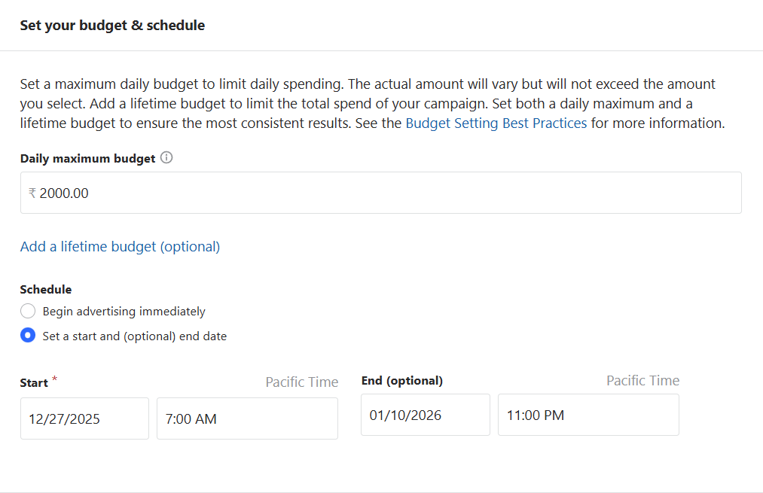c) Audience targeting (location, topics, interests, keywords, etc.)
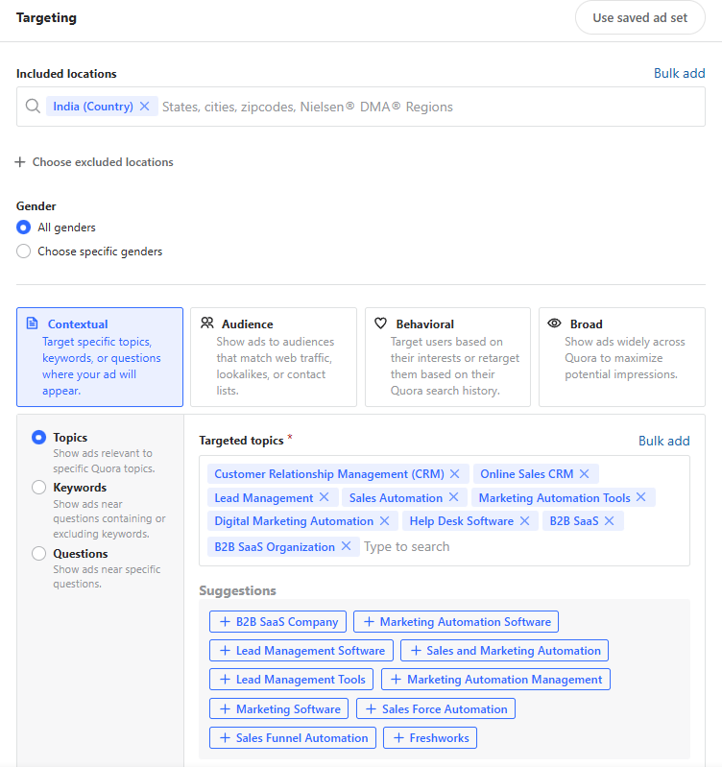
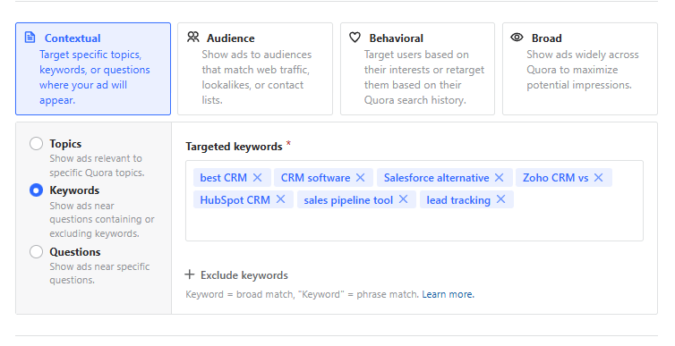
e) Ad preview (image + copy + CTA)
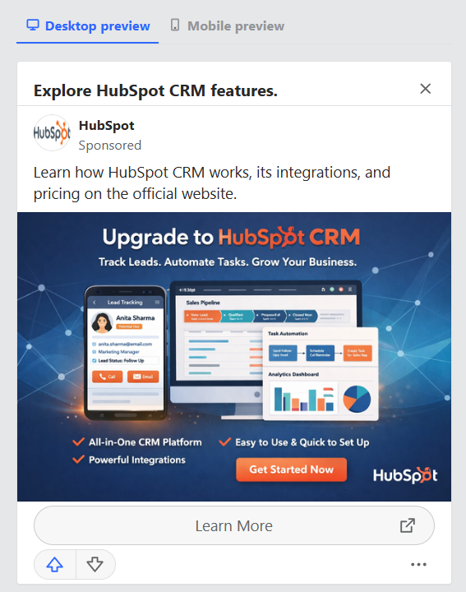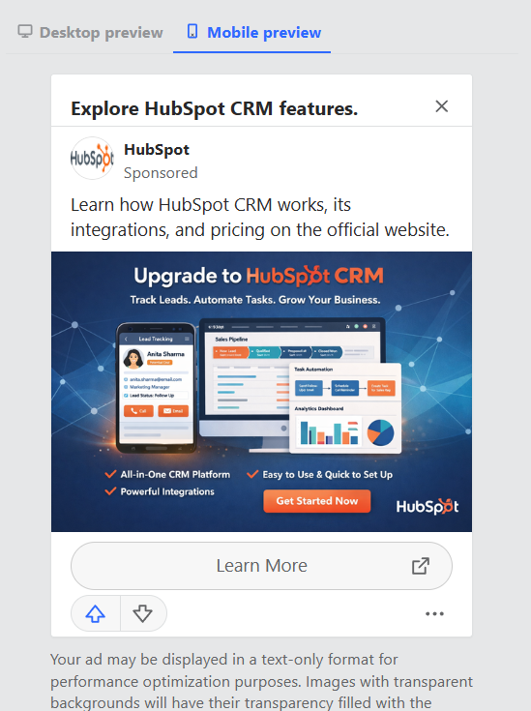
f) Estimated campaign results
It is not available in Free version.

